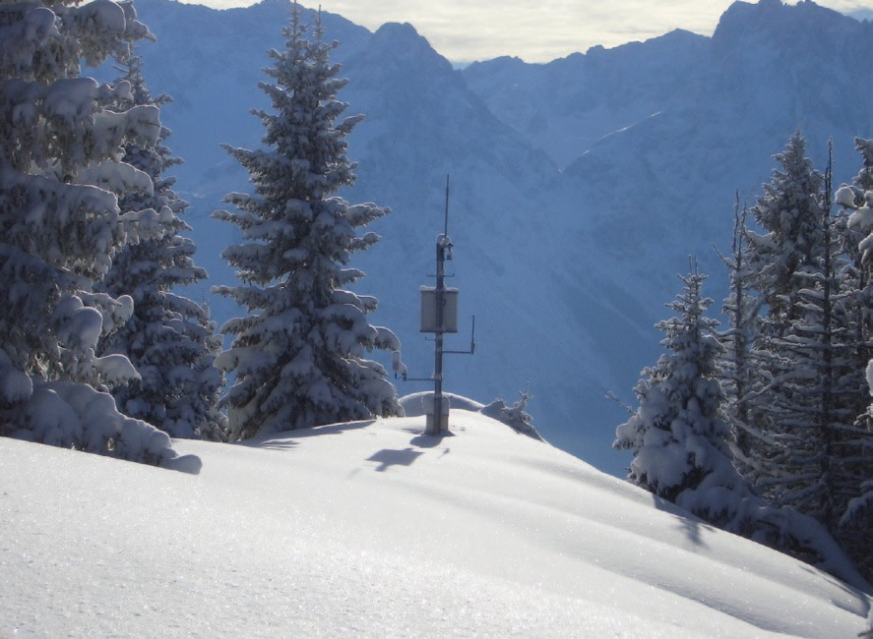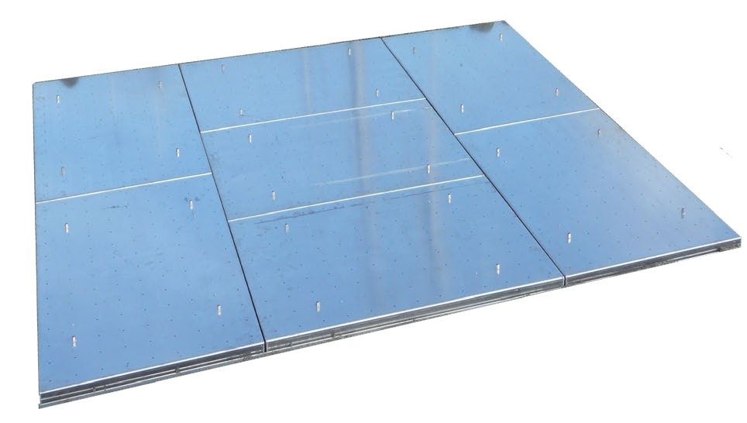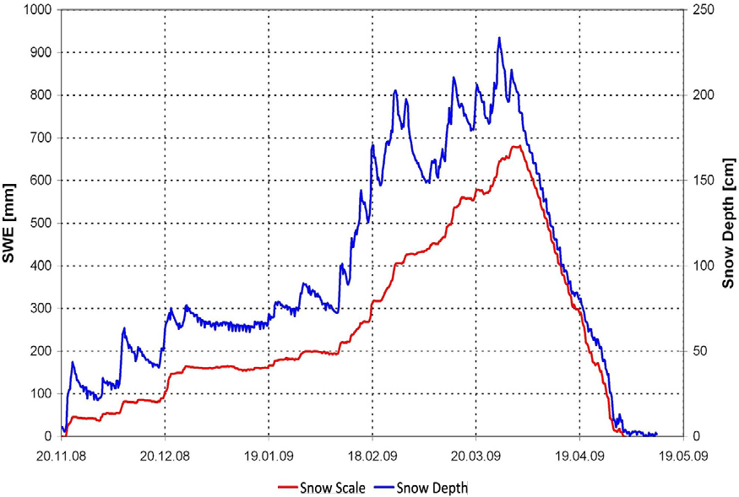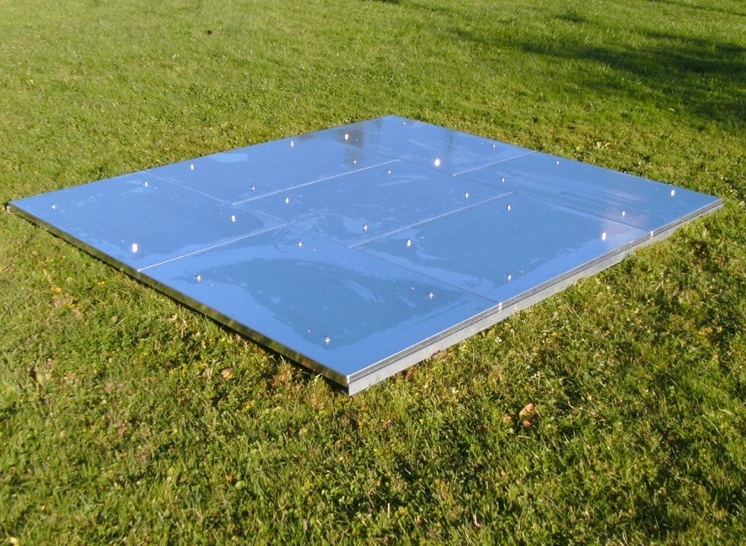
so
er

SSG
M E S S T E C H N I K
Snow Scale SSG, precision measuring device for the Snow-Water-Equivalent (SWE) of a snow pack

Features and advantages

- Continuous measurements of the Snow-Water- Equivalent (SWE)
- Reduces effects of ice bridging to a minimum
- Optimises thermal flow between sensor and ground for high accuracy during the melting process
- Robust and long-lasting aluminium construction
- Measures up to:
200 / 500 / 1.000 / 2.000 / 3.000 mm of SWE
- No antifreeze liquid required
- Simple system integration
- No preparation of the measuring site required

EN

Introduction

Description
The SSG Snow Scale is a precision Snow-Water- Equivalent measuring device which is developed for quick and easy installation and implementation in the field. The SSG uses specially designed aluminium plates for SWE measurement which guarantee accurate measuring values. A broad frame of panel minimises the effects of ice bridging. The use of lightweight aluminium materials minimize thermal resistance improving heat

Function
The working principle of the SSG is based on the measuring principle of load cells. The sensor consists of seven perforated panels of a size of 80 x 120 cm each. The center panel and six surrounding panels allow water to percolate through the sensor. The perforated panels minimizes thermal differences between the sensor and the ground. The surrounding panels act to buffer the center panel, where the SWE is measured,

flow throughout the device for better emulation of natural conditions. The SSG has an analogue 4 - 20 mA output. Therefore integration and connection to weather stations or other signal processing systems are kept easy and simple.

from stress concentrations which are developed along the perimeter of the sensor. This system allows accurate measurements even during periods of rapid snow settlement followed by large snow accumulations.

Installation guide
The SSG is designed for modular and easy installation and maintenance in the field. The snow scale consists of an instrumented center panel surrounded by six panels that act to buffer the center panel from edge stress condition (Figure 1). For the assembling an even underground is necessary. To avoid significant influence on the weight measurement a maximum

inclination of 5° should not be exceeded. The snow scale can be sunk in the ground or mounted lying on the surface. The seven aluminium plates are simply screwed on a frame which consists of six flat profiles and two L-profiles. The SSG is supported by angle beams to provide strength and stiffness.

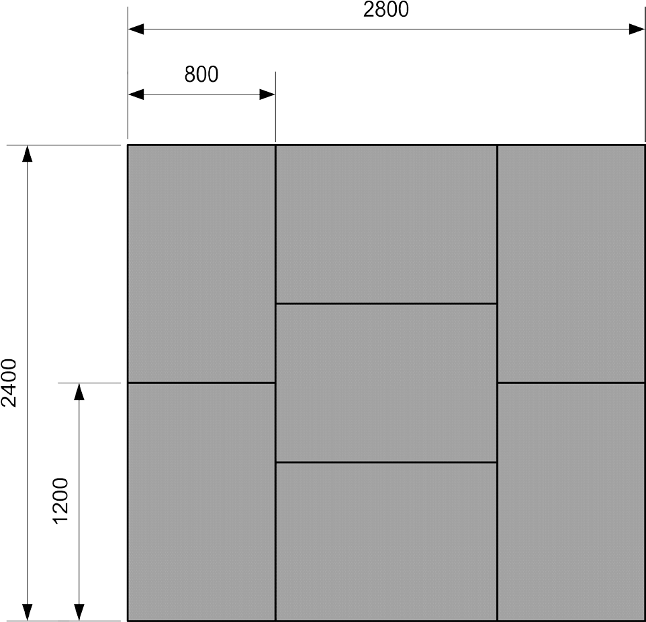
Figure 1: SSG snow scale design

Set up example

The measuring device can be installed on an up to 5° incline. For optimal measuring values the site should be prepared as followed: Remove the ground and fill the trench with a thin layer of gravel so the SSG is flush with
the surrounding ground. Finally the aluminium panels and load cells rest on the linkage, placed on this gravel pad (Figure 2).

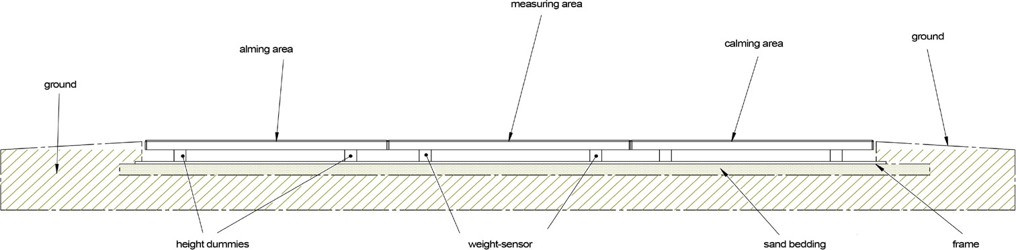
Figure 2: SSG snow scale set up

Set up example:
The SSG snow scale has been set up in the ground. So the SSG and the surrounding ground are on the same level.

The aim is that the snow scale takes over the characteristics of the ground and therfore the measuring values should have a higher informative value.

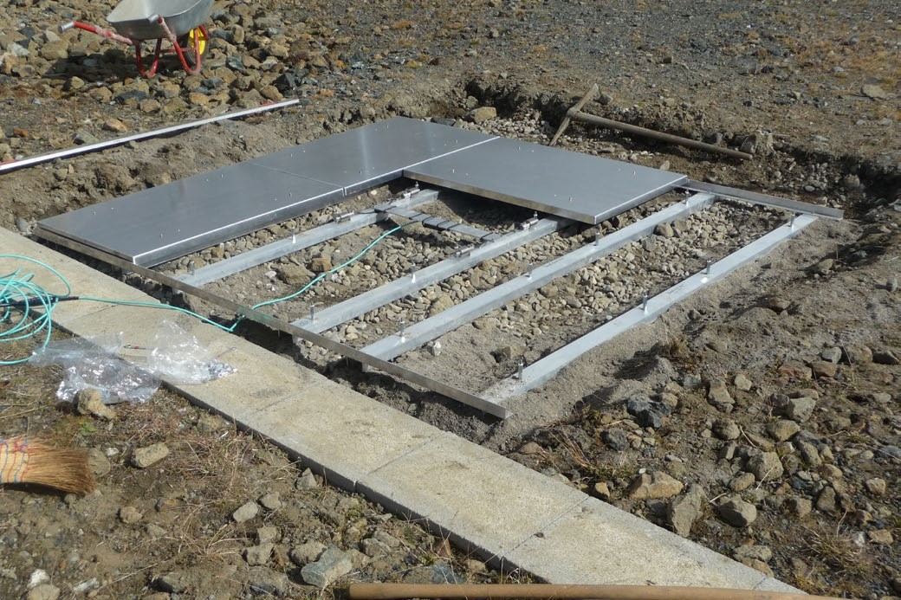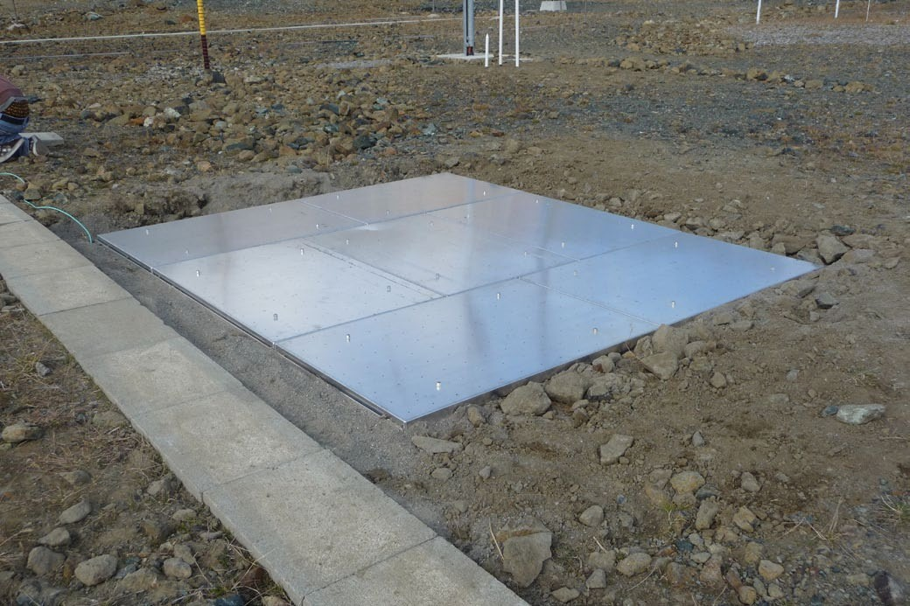

Figure 3: Preparation measuring site Figure 4: Installed SSG snow scale

Application areas

Application areas | Water resource management
Application areas | Flood risk management
Application areas | Monitoring of precipitation
Application areas | Automatic snow load monitoring

Technical Data

General
Measurement range | 4 ranges:  0 ... 200 mm SWE  0 ... 500 mm SWE  0 1.000 mm SWE  0 2.000 mm SWE  0 3.000 mm SWE
Resolution | 0.1 Kg/m² ≙ 0.1 mm SWE *
Accuracy | 0.3 % (FS) *
Measuring surface | 6.72 m²
Total weight SSG | 110 Kg
Dimensions SSG (mm) | L = 2800  W = 2400  H = 103
Protection | IP 68
Power supply | 10 ... 30 VDC
Power input | max. 70 mA
Operating temperature | -40 ... 80°C
Max. inclination | 5°
Output | SSG 200 4 - 20 mA ≙ 0 ... 200 mm SWE  SSG 500 4 - 20 mA ≙ 0 ... 500 mm SWE  SSG 1.000 4 - 20 mA ≙ 0 1.000 mm SWE  SSG 2.000 4 - 20 mA ≙ 0 2.000 mm SWE  SSG 3.000 4 - 20 mA ≙ 0 3.000 mm SWE
Order information | SSG 200: range 0 ... 200 mm SWE  SSG 500: range 0 ... 500 mm SWE  SSG 1.000: range 0 1.000 mm SWE  SSG 2.000: range 0 2.000 mm SWE  SSG 3.000: range 0 3.000 mm SWE
Others | Connecting box with lightning protection
Packaging
Europallet (cm) | L = 120  W = 80  H = 100  Weight: about 130 kg
Tube (cm) | L = 320  Ø = 25  Weight: about 42 kg

* All declarations of weight and accuracy refering to standardised weights.

